Performance Metrics

| **Date** | 24 November 2022 |
| --- | --- |
| **team id** | | PNT2022TMID37024 | | --- | |
| **Project title** | | AI Powered Nutrition Analyst for Fitness Enthusiasts | | --- | |

1. Confusion Matrix

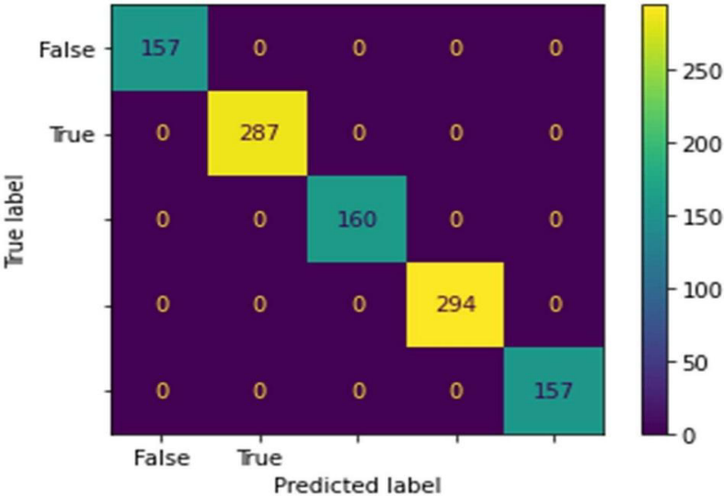

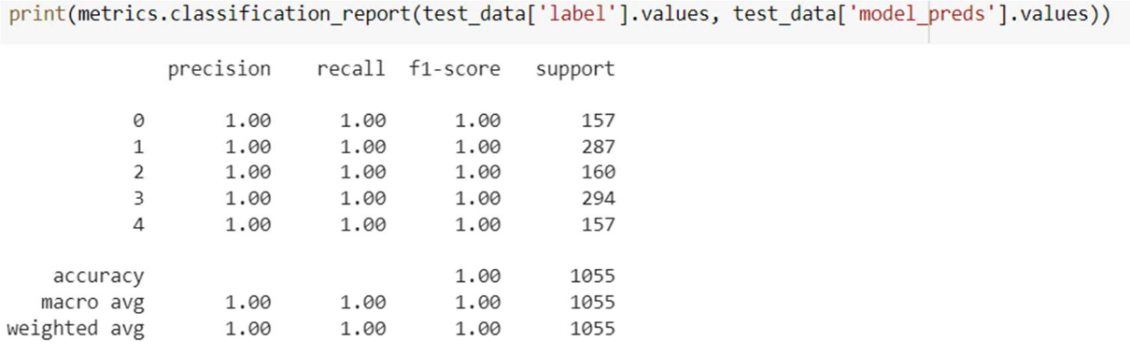

2. Accuracy – 100 %



3. Precision – 100 %



4. Recall – 100 %



5. Specificity – 100 %



6. F1-Score – 100 %

